**User's Guide**

**The project is deployed:** [**https://sjsu-letitfly.herokuapp.com/**](https://sjsu-letitfly.herokuapp.com/)**.** Skip to *Usage* for the application tutorial. It is also open-source for users who wish to install, make modifications to suit their needs, and run the application on their own server. Installation steps are listed below.

**Installation**

1. Install MySQL from <https://dev.mysql.com/downloads/mysql/>
   1. Make sure to choose your operating system.
   2. Remember username and password. You will need them for next step.
2. For *nix, open terminal. For Windows, open command line and log in to your database with commands below.

$ mysql -u root -p (It will ask the password)

1. Create database

mysql > CREATE DATABASE flask_api;

1. Ctr-d to exit from MySQL
2. Install python 3.6 from here <https://www.python.org/downloads/>
3. Download virtualenv

$ pip install virtualenv

1. Clone the repository from GitHub and open .env file

git clone <https://github.com/YukiKuroshima/CS160.git> --branch Debug_insecure_origin

cd CS160/letitfly/

virtualenv venv

touch .env

open .env

(.env will be opened in your text editor)

1. Paste below into .env file. Make sure to change <username> and <password> to your MySQL username and password

source venv/bin/activate

export FLASK_APP="run.py"

export SECRET="some-very-long-string-of-random-characters-CHANGE-TO-YOUR-LIKING"

export APP_SETTINGS="development"

export DATABASE_URL="mysql://<username>:<password>@localhost/flask_api"

1. Start the virtual environment

source .env

1. Install modules

pip install -r requirements.txt

1. Make sure you are in /CS160/letitfly

$ pwd

If you are not in /CS160/letitfly change directory

1. Initialize the database

python manage.py db init

python manage.py db migrate

python manage.py db upgrade

1. Start the server

python run.py

1. localhost:5000 on your browser to check the website.

**Usage**

1. Log in

Open your browser and type <http://localhost:5000/>  
You will see this page.

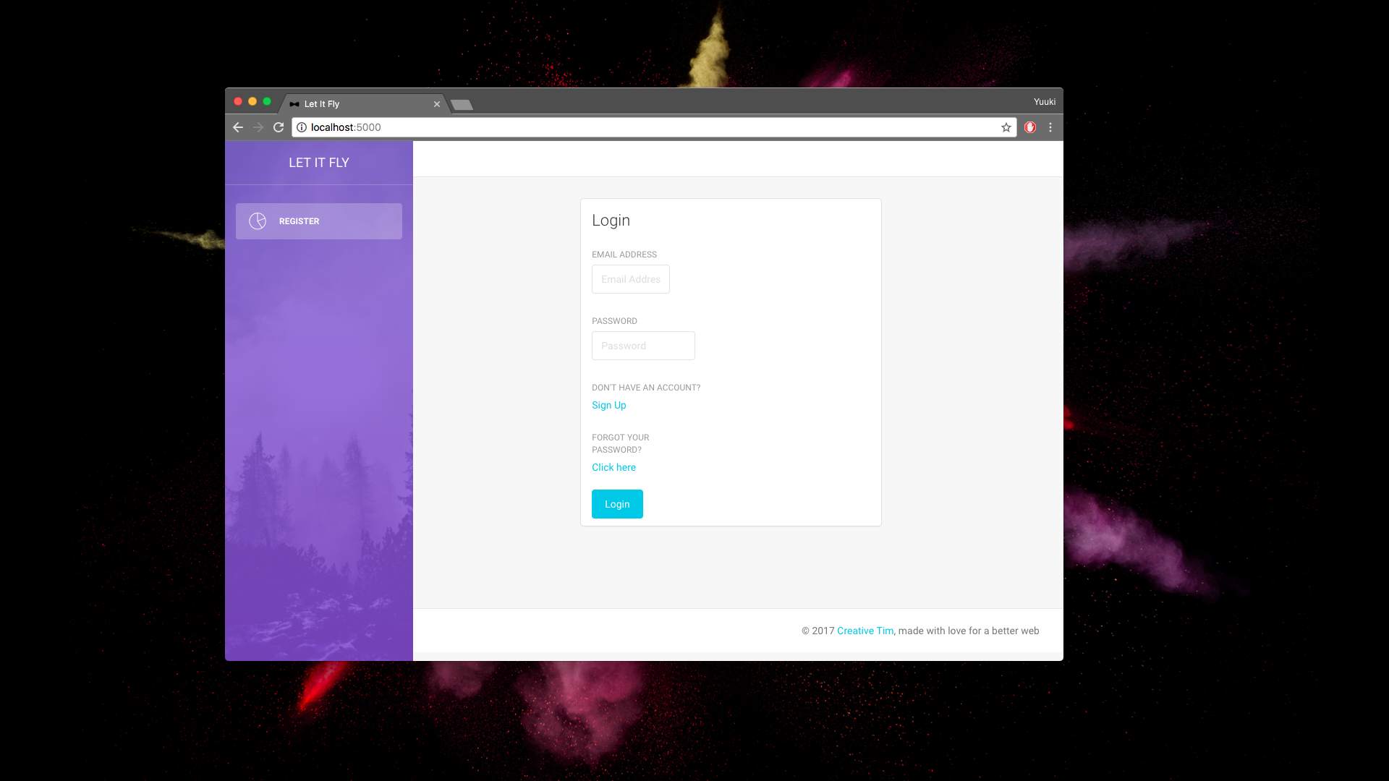In this page, you can login, or if you do not have an account yet, you can click "Sign Up" and create new account.

Since it is first time for you to use this awesome app, let's create new account. Please click "Sign Up" and it will take you to the registration page.

1. Register

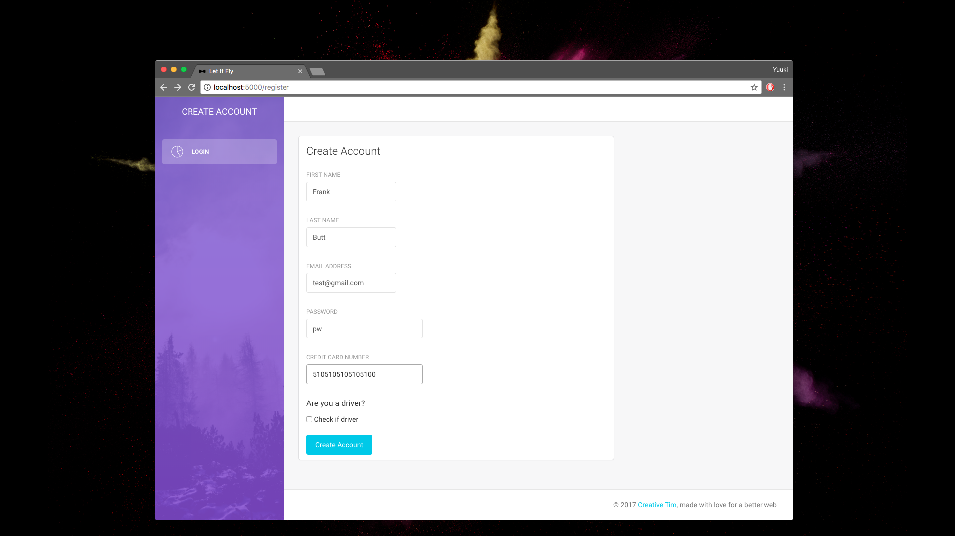

This is the register page. You type your information and the website will store them in the database. If you want to use this website as rider, which means looking for someone to pick you up, make sure to leave the Check if driver blank. Fill up all the information and click the Create Account. If you are a driver, make sure to click the Check if driver. It will take you to the request ride page.

1. Request a ride

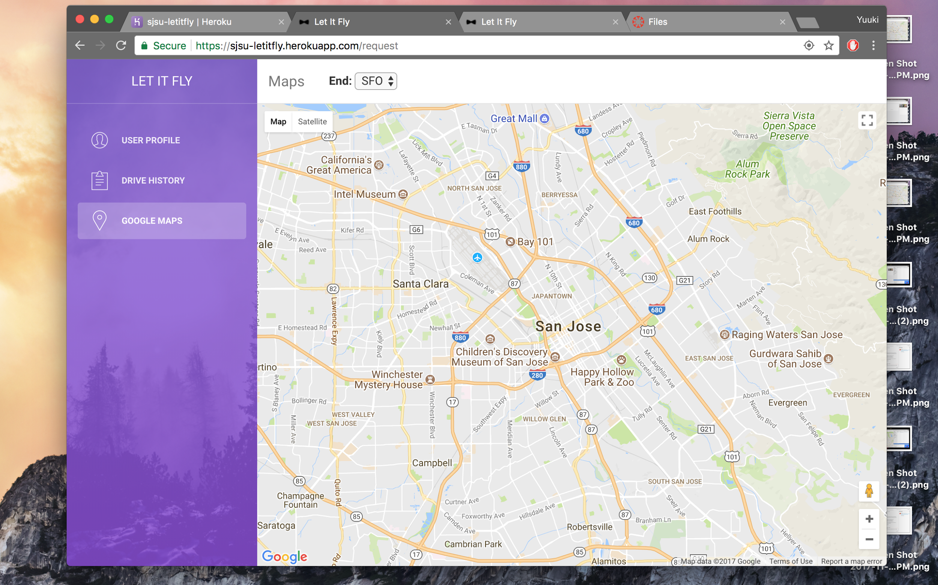

Only client can access to this page. In this page, client can request a ride. In dropdown, please choose the airport that you want to go.

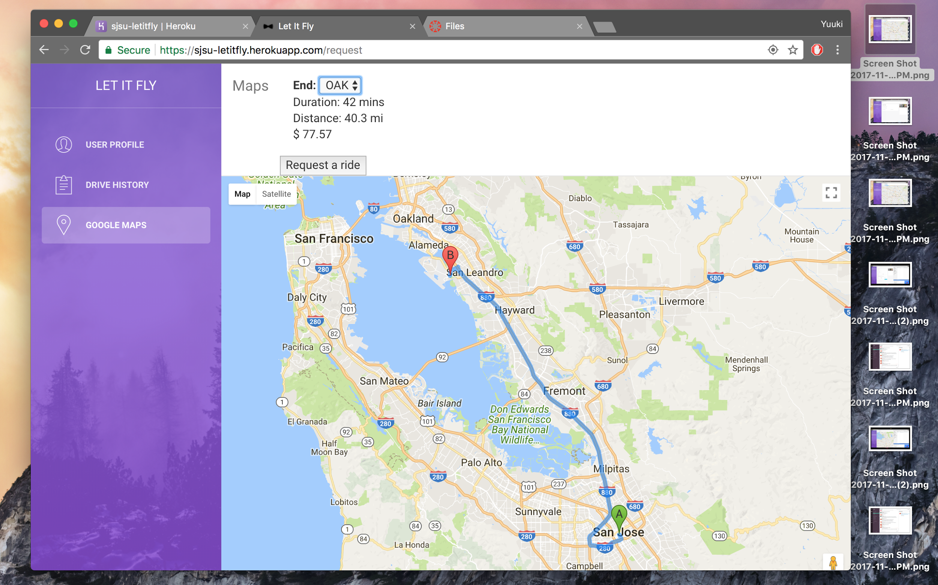

After choosing the airport, you will see the duration, distance, and price. If you are happy with them, please click the "Request a ride" button. It will take to you the waiting page.

1. Wait for a driver to be assigned

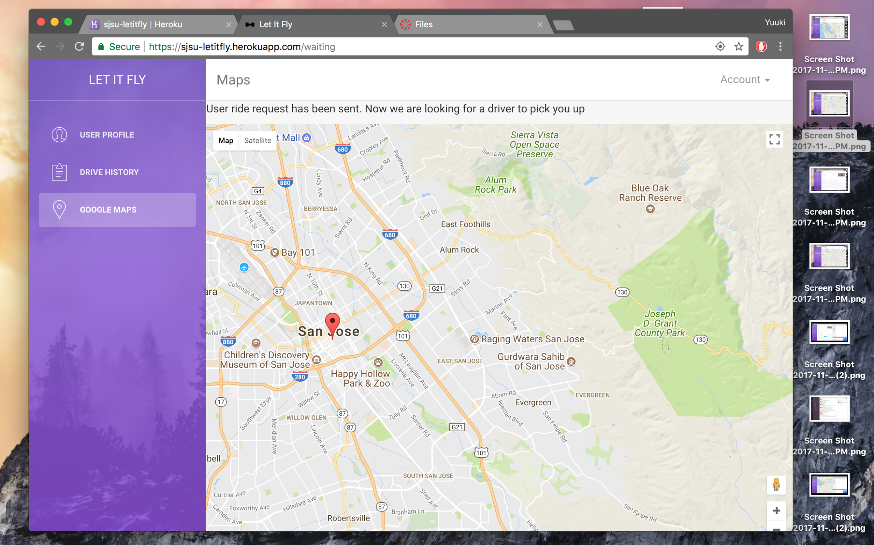

In this page, you are waiting for a driver to be assigned to you.

1. Wait for a driver to pick client up

Once a driver is assigned, you will see this page.

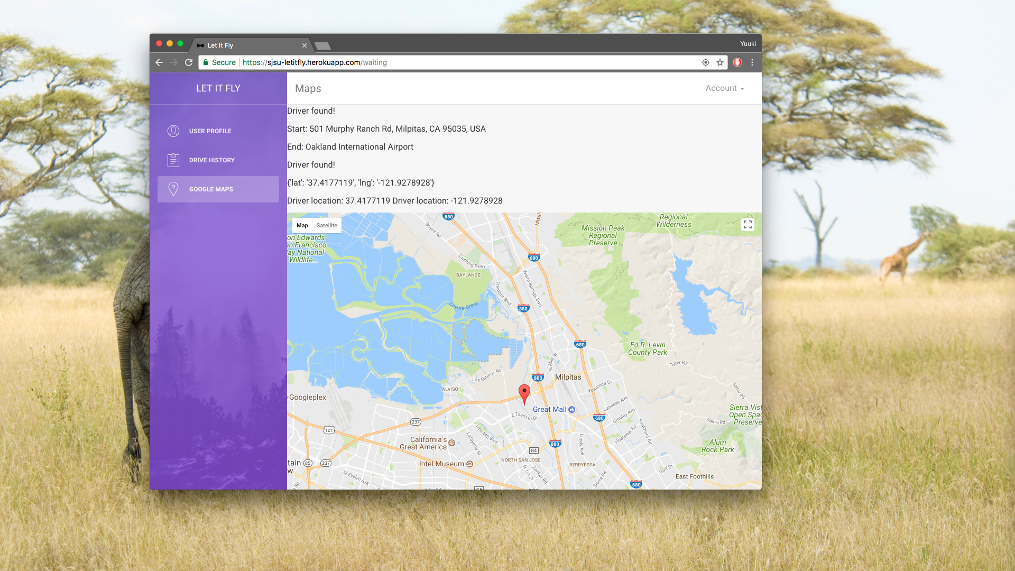

This page shows that your status has changed and you have a driver coming to pick you up.

1. Search ride requests

This page is for drivers to search the ride requests near them.

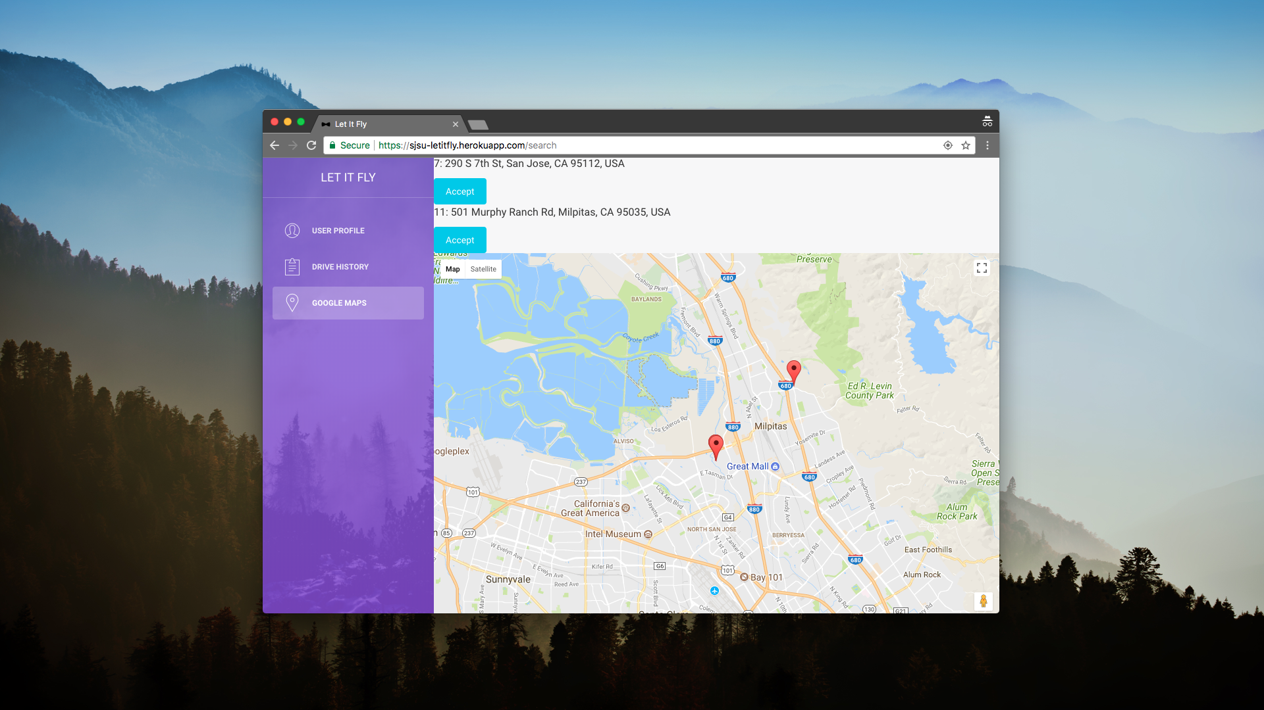

You can see clients' location on the map and also the list of ride request on upper part of page. If you would like to pick them up, please click the choose button. It will take you to the pick up page.

1. Pick up a client

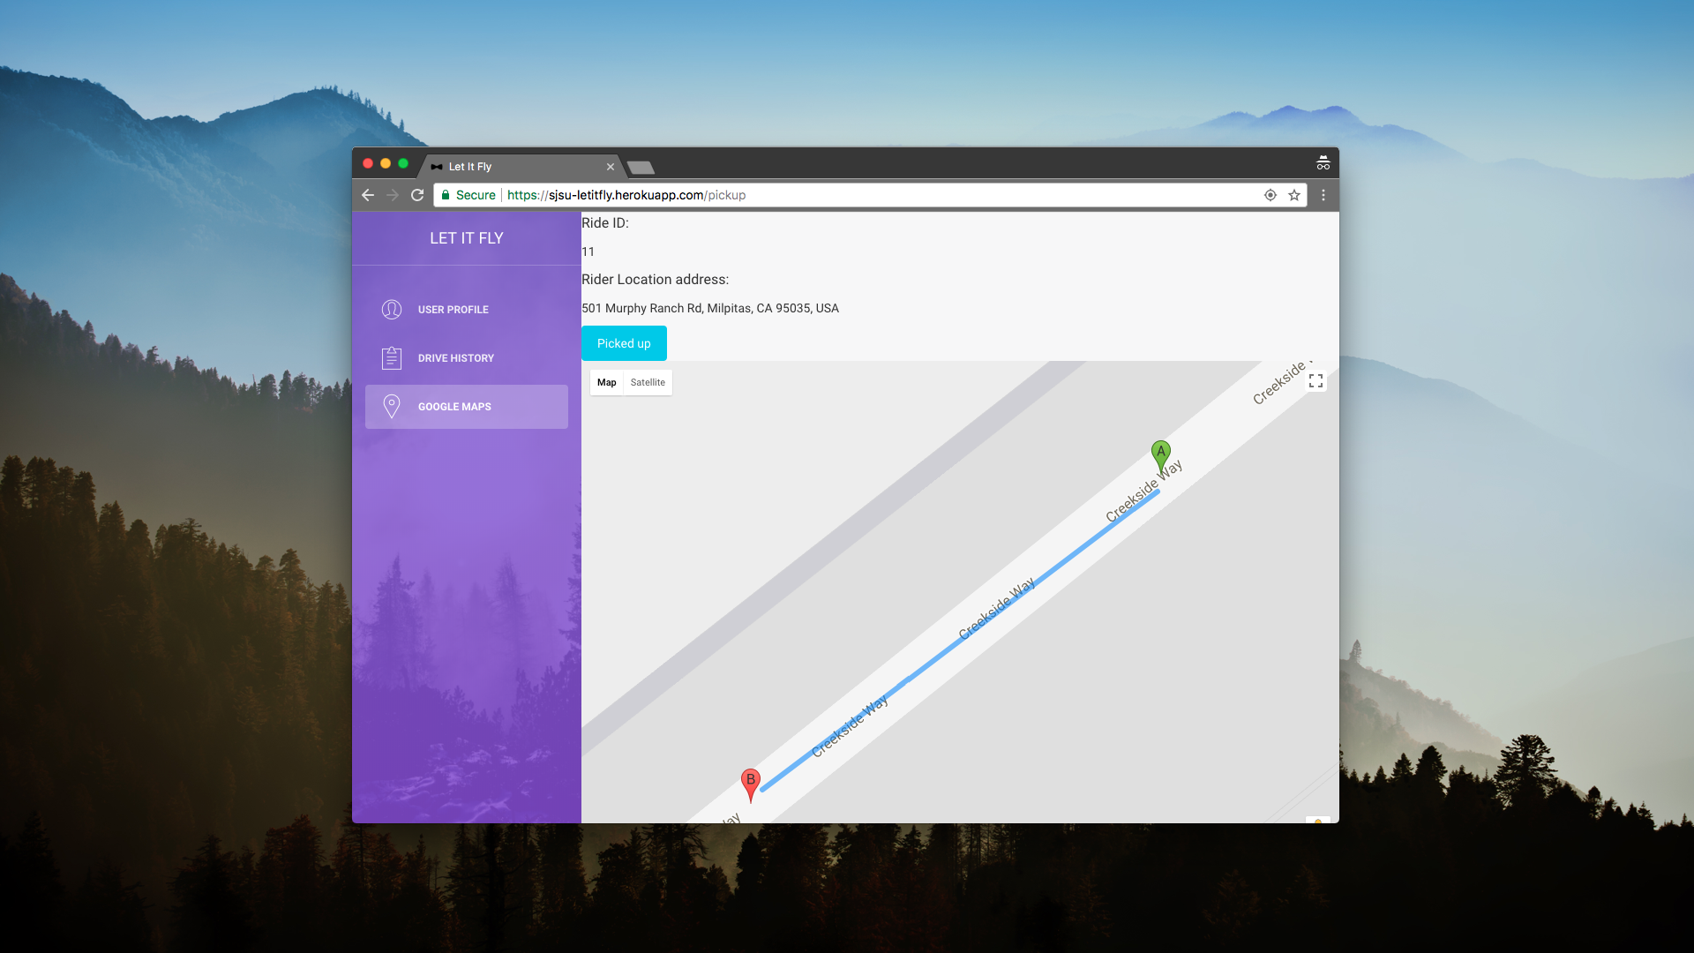

In this page, you as a driver can see where the client waiting for you to be picked up. If you picked them up, please click the picked up button.

1. Drive the client to the destination

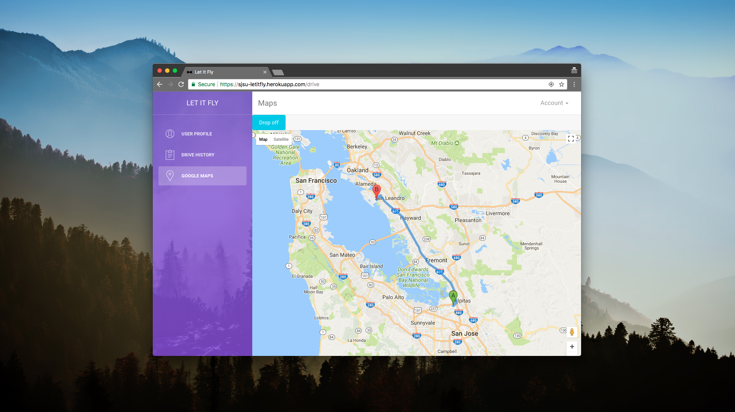

Once you picked your client up, you will see the route to the destination that your client want to go. After dropping them off at the destination, please click drop off button.

1. Payment information

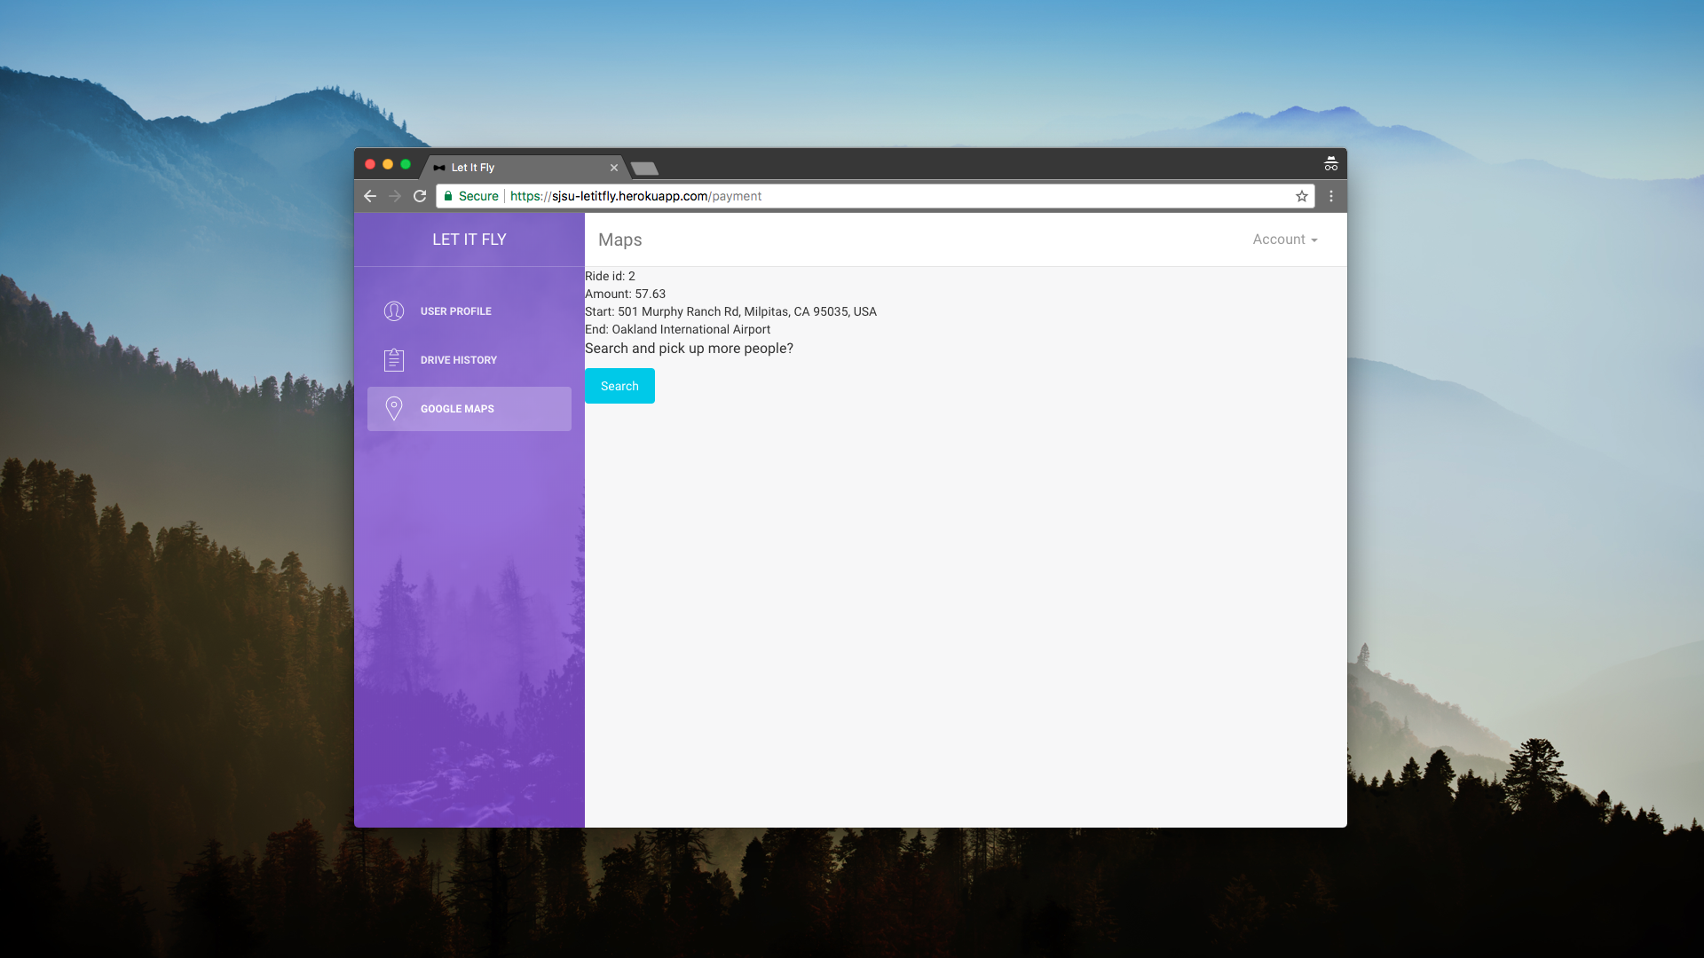

After dropping them off, you can see the detail information of the ride you just finished. If you are energetic enough, and willing to pick up more people please click search button and it will take to you to the search page.

1. View the ride history

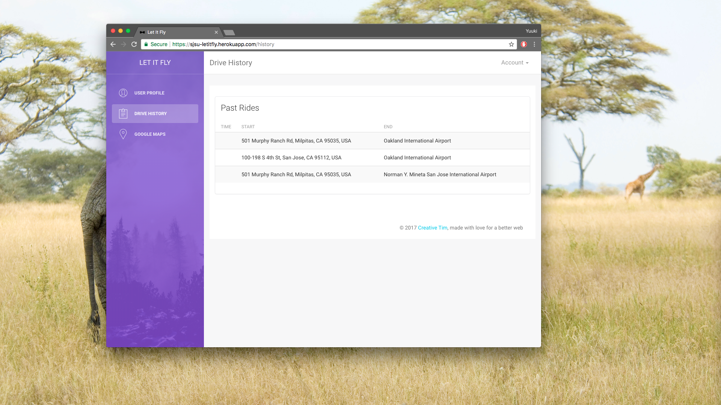

If you want to see the history of your rides, please click the Drive History button on the left of page. It will show the details of your past rides.

1. User profile page

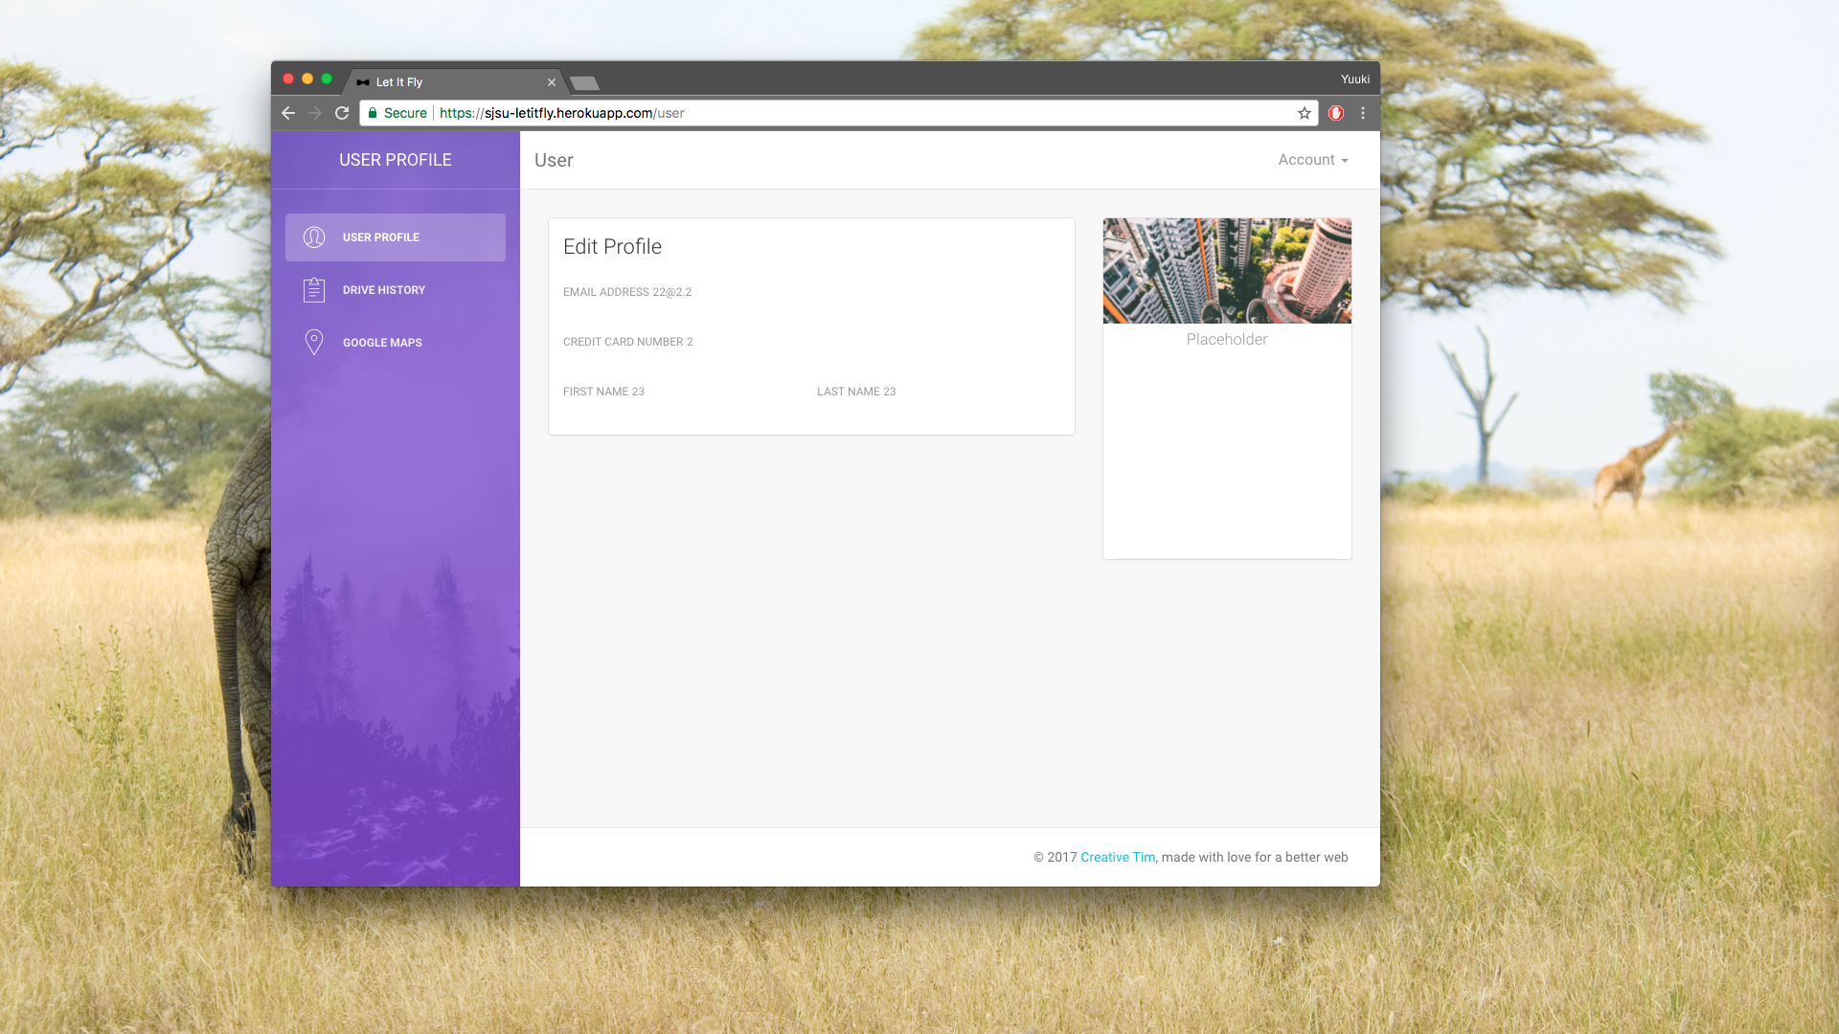

You can also check your profile by clicking the User Profile button on the left of your page. It will show the information about your account.

1. Log out

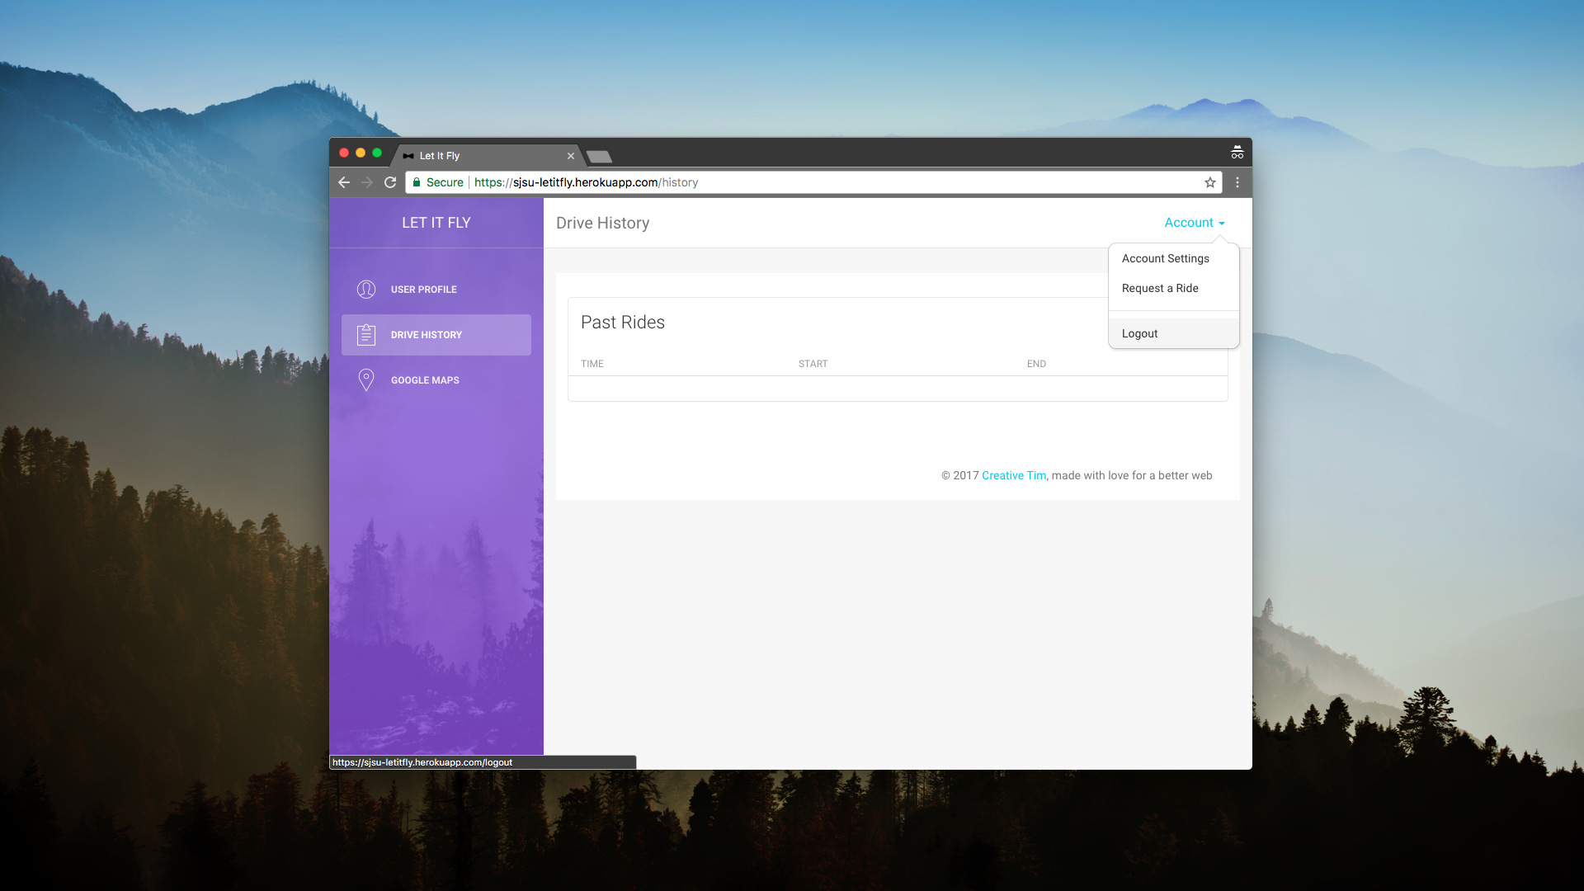

When you are done with using our app, you can click Logout button on the top right corner of page and exit from the app.